Zombie Mall Survival - Student Worksheet

Scenario:
You are in the hallway of a shopping mall. People are running everywhere. Your group of 10 includes:
- A mother with a baby (needs formula milk and nappies)
- An elderly man in a wheelchair (limited mobility)
- People of different cultures and religions (dietary restrictions)
- Several wounded individuals (need medical care)
- Everyone is hungry and thirsty as well as scared
Challenges:
- Locked exits
- Zombies roaming escalators and corridors (they broke in through smashed glass doors)
- Limited time before zombies reach your hallway
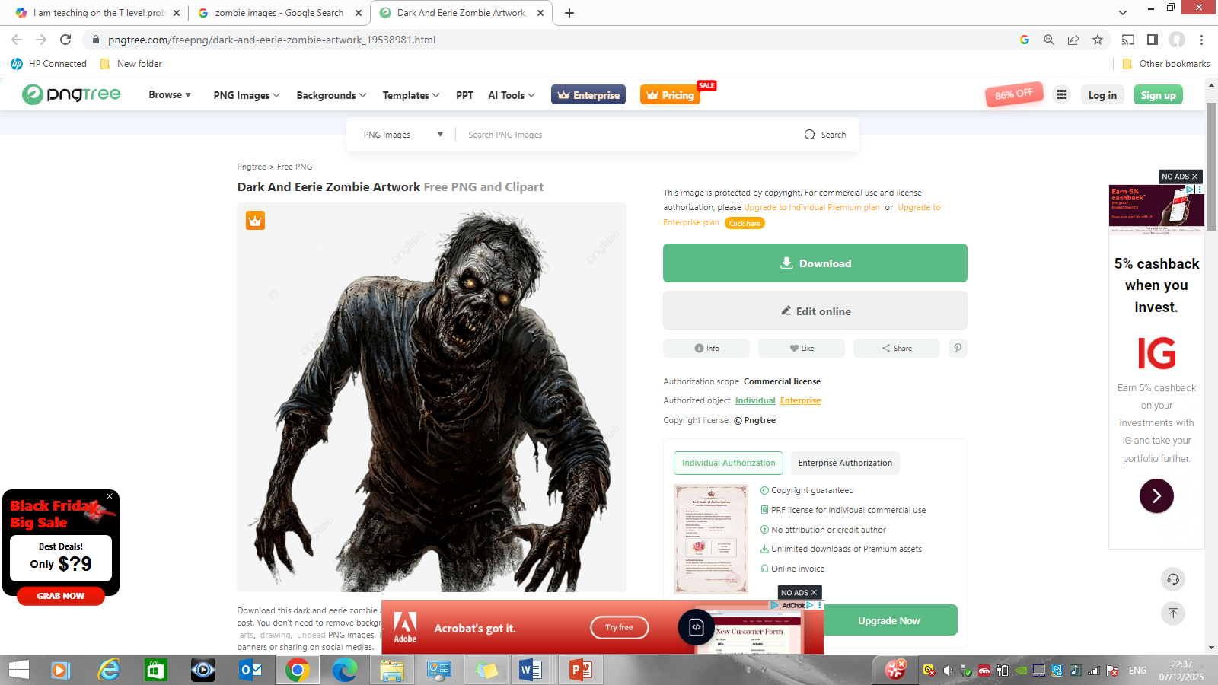
- You start with no supplies

Your Task:
- Identify the main problems from the scenario
- Break each problem down into smaller actions (decompose)
- Arrange actions in a logical order
- Explain why each action is important
- Think about different survivors and their needs

Main Problems:
- Food & Drink
- Medical Care
- Safe Route & Shelter

Go around shopping center collect essentials, and weapons.
Loot what you can
Use the wounded people’s blood as bait for the zombies
Pile up all the explosives collected
Wait near an exit
Onse the zombies are by the explosives blow it up and run out the exit

